**E-Commerce Cosmetic**

**A Project Report**

Submitted in partial fulfillment of the requirements for the award of the degree of

**Master of Computer Application**

**Submitted By**

**Archana Varshney**

**( University Roll No.: 1900290140009)**

**Batch: 2019-2022**

**Under the supervision of**

**Miss Neelam Rawat**

**(Associate Professor)**



**DEPARTMENT OF COMPUTER APPLICATIONS**

**DR.APJ ABDUL KALAM TECHNICAL UNIVERSITY**

**LUCKNOW**

**(Formerly Uttar Pradesh Technical University, Lucknow)**

**(JUNE 2022)**

**Signature Signature**

**(Name of Student) (Name of Mentor)**

**DISSERTATION REPORT**

**ON**

**E-Commerce Cosmetic**

**SUBMITTED BY : Archana Varshney**

IN PARTIAL FULFILLMENT OF

THREE YEAR MASTER OF COMPUTER APPLICATIONS PROGRAMME



**DR.APJ ABDUL KALAM TECHNICAL UNIVERSITY**

**LUCKNOW**

External Supervisor: Internal Supervisor*:*

**Miss Neelam Rawat**

**KIET,Ghaziabad**

**DECLARATION**

I, **Archana varshney**, **1900290140009** , hereby declare that the work done by me on “Manual And Automation Testing at Cloud Analogy from March, 2022 to PRESENT, under the supervision of, **Mr. Saurabh Pathak (QA Team Lead), Cloud Analogy Softech Pvt. Ltd.** and **Miss Neelam Rawat Assistant Professor, KIET Group Of Institutions**, is a record of original work for the partial fulfillment of the requirements for the award of the degree, **MCA** (Master of Computer Application).

**Name: Archana Varshney**

**Enrolment No.:**1900290140009

Signature:

**CERTIFICATE**

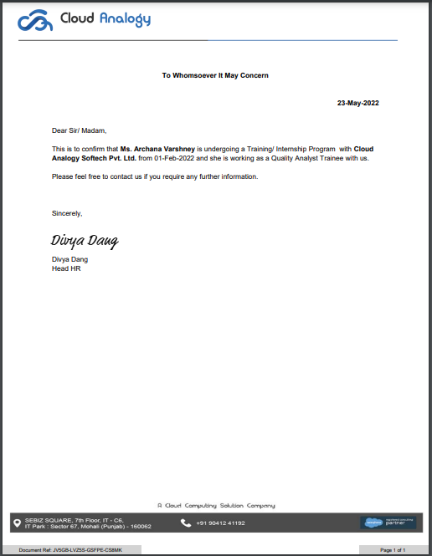

**ABSTRACT**

Mary kay Inc. Starting in 1963 is an American Privately owned MLM (multi level marketing company) which sells cosmetics products.Company founded by Mary Kay Ash. It is made for both Classic and Lightning experience parts of Salesforce.

The motive of this project is women's empowerment.Project using almost all the clouds of salesforce like service cloud. , Agreement ,Community cloud, commerce cloud, analytics cloud, Identity.

Project is live in 30 markets of 4 regions

• EUR

• APR

• NAR

• AMR/LAR

We have 4 Regions:

APR(APAC) (Asia Pacific Region): 5 Markets [(Grp-1)MY,SG] [(Grp-2)PH,TW,HK]

NAR (North America Region): 2 Markets [ CA,US ]

EUR(European Region): 17 Markets [ AM,BY,CH,CZ,DE,ES,IE,KZ,LT,MD,NL,PL,PT,RU,SK,UA,UK ] (DE,NL,CH (Grp-1)) (ES,PT (Grp-2)) (CZ,SK,PL,LT [ Grp-3 ])

LAR/AMR (Latin America Region): 6 ( BR,CO,PE [Grp-1] ), (MX,AR,UY [Grp-2])

In MK we work as a QA in which we follow the Agile methodology where software gets developed in a more sophisticated way and with an incremental testing approach. In this we tested each and every component immediately so that it reduces the risk factor in the process. In this Each sprint begins with a planning meeting. During the meeting, the product owner (the person requesting the work) and the development team agree upon exactly what work will be accomplished during the sprint. The development team has the final say when it comes to determining how much work can realistically be accomplished during the sprint, and the product owner has the final say on what criteria need to be met for the work to be approved and accepted.

**ACKNOWLEDGEMENT**

I would like to extend my gratitude to my teachers and my Training and Placement Department as because of them only I was allowed to pursue an internship in my Final Semester. I would like to credit them for guiding me to receive and to carry out my Internship Cloud Analogy, Mohali.

I would like to thank all my professors and fellow batch mates who helped through every phase of the 3 years of my life which I consider to be one of the most important and crucial years.

This work would not have been possible without the support of my supervisors under Mr. Saurabh Pathak (QA Team Lead) for the QA Trainee Role at Cloud Analogy, Mohali for constantly having faith in me and giving me the freedom to work on desired projects and being honest and critical to my performance.

Table of Contents

DECLARATION 3

CERTIFICATE 4

ABSTRACT 5

ACKNOWLEDGEMENT 6

CHAPTER 1 7

1.1 Project Description 8

1.2 About Project Undertaken 9

CHAPTER 2 10

2.1 What We Do In The Project 11

2.2 Testing Methodology being followed in Cloud Analogy: 12

2.2.1 Agile Methodology 13

2.2.2 JIRA Tool 14

2.2.3. Tricentis TOSCA 15

2.2.4. Salesforce Lighting Experience 16

2.4 Workspace and Builder Experience 17

2.5. Community Cloud 18

2.6 Commerce Cloud 19

CHAPTER 3 20

3.1. Requirements 21

3.2. IMPORTANCE 22

CHAPTER 4 23

4.1.Roles and Responsibilities 24

4.2.Advantages 25

4.3.Testings Performed 26

4.4. ACTIVITIES AND EQUIPMENTS HANDLED: 27

CHAPTER 5 28

DATA FLOW DIAGRAM 29

5.1 Level 0 30

5.2 Level 1 31

5.3 Level 2 32

CHAPTER 6 33

6.1. CHALLENGES FACED AND HOW I TACKLED THEM 34

6.2. LEARNING OUTCOMES 35

CHAPTER 7 36

7.1. Q-Test 37-38

7.2 Uses of qTest 38-40

7.3 qTest - Login 40-43

7.4. DASHBOARD: 43-50

7.5 qTest - Add a Project 50-54

CONCLUSION 55

FUTURE PERSPECTIVE 56-58

References: 59-61

**CHAPTER -1**

**INTRODUCTION**

**1.1 PROJECT DESCRIPTION**

In the initial days of the internship, we were given product training on Salesforce and some Basic methodologies for testing for 1 months. As Cloud Analogy has their prime work on Salesforce through which only their maximum revenue comes for them, so we had to undergo this Advanced Level Product training on Salesforce.

I worked in the Quality Assurance Team as an Intern in performing the Manual Testing and Automation testing for the Salesforce CRM product. As a QA I also worked on the JIRA tool for configuring the Requirements Tickets , Track the Bug and Issues and perform Agile Methodology.

In the SF part i work on Community cloud and configure the Admin part as well and Lighting Builder,

**1.2. About Project Undertaken**

Mary kay Inc. Starting in 1963 is an American Privately owned MLM (multi level marketing company) which sells cosmetics products.Company founded by Mary Kay Ash. It is made for both Classic and Lightning experience parts of salesforce. The motive of this project is women's empowerment.Project using almost all the clouds of salesforce like service cloud. , Agreement ,Community cloud, commerce cloud, analytics cloud, Identity .

Project is live in 30 markets of 4 regions

• EUR

• APR

• NAR

• AMR/LAR

**Different environments, regions and markets in MK.**

There are 4 env in MK.

1.DEV INT

2.QA

3.UAT

4. PROD

**CHAPTER -2**

**LITERATURE REVIEW**

**2.1 JIRA**

Jira Service Management is Alsatian's service management solution for all teams. Jira Service Management is designed to help you unlock high-velocity teams by 1) empowering every team to deliver great service fast, 2) bringing visibility to work, and 3) accelerating the flow of work between development, IT, and business teams. Built on Jira, it encompasses deeper service management practices across service request, incident, problem, change, knowledge, asset, and configuration management. JIRA Software is part of a family of products designed to help teams of all types manage work.4) Originally, Jira was designed as a bug and issue tracker. But today, Jira has evolved for all kinds of use cases, from requirements and test case management to agile software development.5) JIRA is a project management tool for tracking the issues and bugs. It is widely used as an issue-tracking tool for all types of testing. It supports MySQL, Oracle. It can be used in Help desk, Support and Customer Services to create tickets and track the resolution and status of the created ticket.6) Create user stories and issues, plan sprints, and distribute tasks across your software team. Prioritize and discuss your team’s work in full context with complete visibility.7) Ship with confidence and sanity knowing the information you have is always up-to-date. Improve team performance based on real-time, visual data that your team can put to use. Every team has a unique process for shipping software. Use an out-of-

the-box workflow, or create one to match the way your team works.8) Ship faster and more reliably by building smarter plans for your team and for your organization. Steps Follow for every SPRINT in JIRA: Create a new sprint9). Go to the backlog of your Scrum project. Step two: Fill the Sprint with stories from your backlog.10) Step three: Add stories to your sprints. Step four: Start your Sprint. Step five: Monitor your team's progress. Step Six: Close the Sprint.

Through JIRA, the Product Managers create tasks for members of our team to work on, complete with its details, due dates, and reminders.11) JIRA helps to utilize sub tasks to breakdown larger items of work. JIRA also allow others to watch the task to track its progress and be notified when it’s completed.12) We can create sub-tasks within the parent task to break down the unit of work into digestible pieces for various members of the team.13) We can also view all tasks on the board to easily visualize each status.14)

**2.2. What We Do In The Project**

In MK we work as a QA in which we follow the Agile methodology where software gets developed in a more sophisticated way and with an incremental testing approach. In this we tested each and every component immediately so that it reduces the risk factor in the process. In this Each sprint begins with a planning meeting. During the meeting, the product owner (the person requesting the work) and the development team agree upon exactly what work will be accomplished during the sprint. The development team has the final say when it comes to determining how much work can realistically be accomplished during the sprint, and the product owner has the final say on what criteria need to be met for the work to be approved and accepted.

**Functionality:**

Whenever anyone wants to join MK , then he should have a valid Recruiter number with him , with the help of that recruiter number new recruit will signup on agreement form and then he has to complete that form which consists of multiple sections with multiple fields . Some sections are Recruiter Information, Personal Information, Address Information, Contact Information ,

Identification Information , Image Upload, Bank Information, Additional Information , Legal Notice and Review Section.

After Completing these all sections he will Navigate to commerce cloud where he will purchase the starter kit which is compulsory for him to purchase. Once he completes the purchase of the starter kit , he will get the consultant number which represents that he has become a part of MK now.

If this new recruit continues his business with MK then after some time he will become the recruiter itself and Now he can recruit new people who want to join MK and as he will recruit more people he will get more business with MK and his career level will increase accordingly.

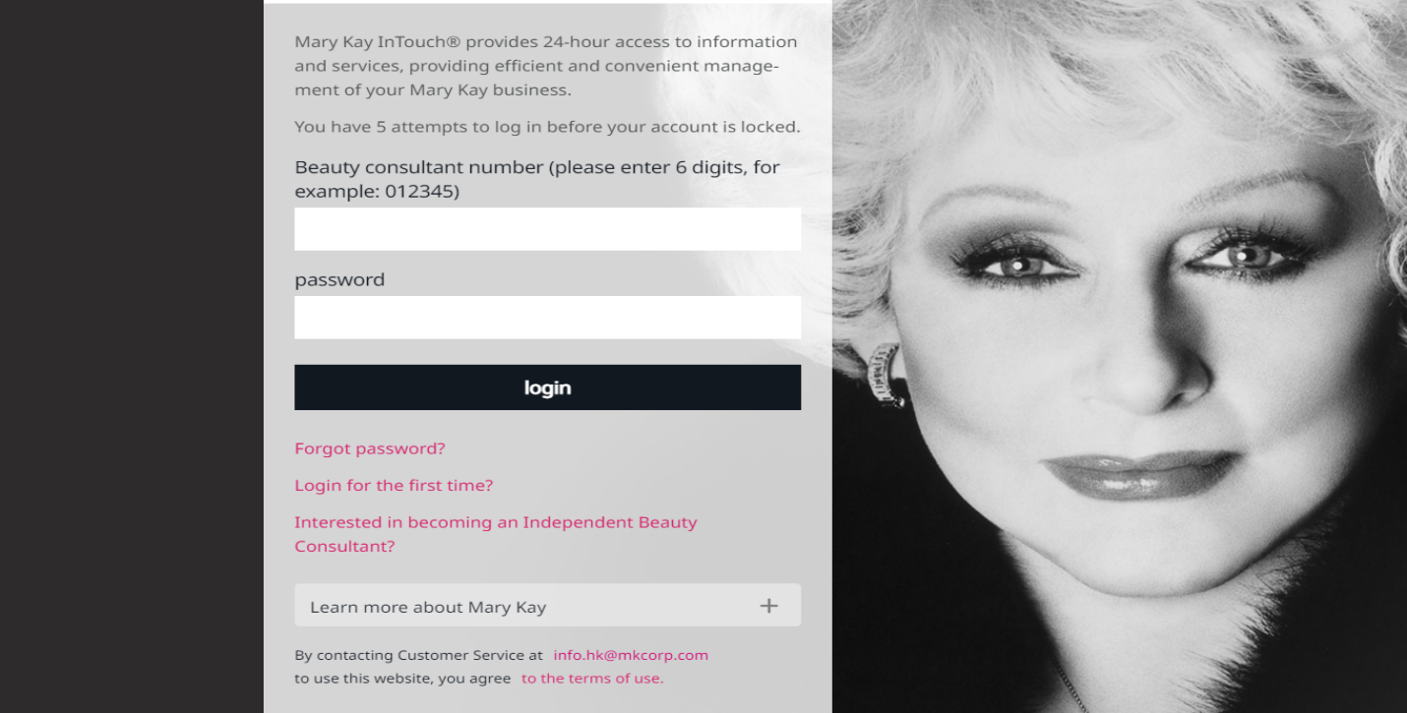

**Fig: View of Marykay InTouch App**

**2.2 Testing Methodology being followed in Cloud Analogy:**

**2.2.1 Agile Methodology:**

It is a more sophisticated software development model with an incremental testing approach. As the requirement varies with time another models could offer a flexible development/test cycle. The agile model mitigate these issues by being more resilient to incorporating changing conditions. Irrespective Of a static process and tool-based approach agile methodology provides more importance to customer and developers. In agile methodology, every component is tested immediately and reduces the risk factor in the process. As it welcomes frequent customer interaction, it demands more time and incurs more pressure upon the testers and developers. Each sprint begins with a planning meeting. During the meeting, the product owner(the person requesting the work) and the development team agree upon exactly what work will be accomplished during the sprint. The development team has the final say when it comes to

determining how much work can realistically be accomplished during the sprint, and the product owner has the final say on what criteria need to be met for the work to be approved and accepted.

**2.2.2 JIRA Tool:**

JIRA is an Incident Management Tool used for Project Management, Bug Tracking, Issue Tracking and Workflow. JIRA is a project management tool used for issues and bugs tracking systems. It is widely used as an issue-tracking tool for all types of testing. An issue helps to

track all works that underlie a project.In JIRA, workflow is a link between two statuses when an issue moves from one status to another.

An issue type scheme determines which issue types will be available to a project or set of projects. It also manages specifying the order in which the issue types will present in the user interface of JIRA, while creating an Issue. Create user stories and issues, plan sprints, and distribute tasks across your software team.

Use an out-of-the-box workflow, or create one that matches the way your team works.

.

Steps Follow for every SPRINT in JIRA:

* Create a new sprint.
* **Step one :** Go to the backlog of your Scrum project.
* **Step two:** Fill the Sprint with stories from your backlog.
* **Step three:** Add stories to your sprints.
* **Step four**: Start your Sprint.
* **Step five:** Monitor your team's progress.
* **Step Six:** Close the Sprint

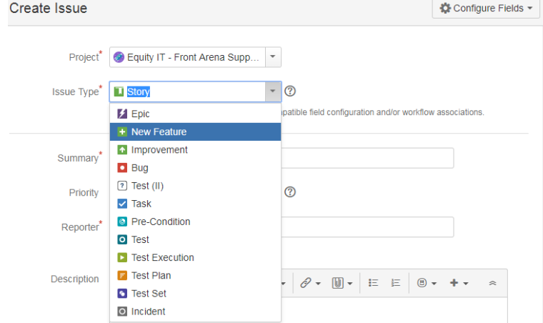

**Fig: Types of Issue In JIRA**

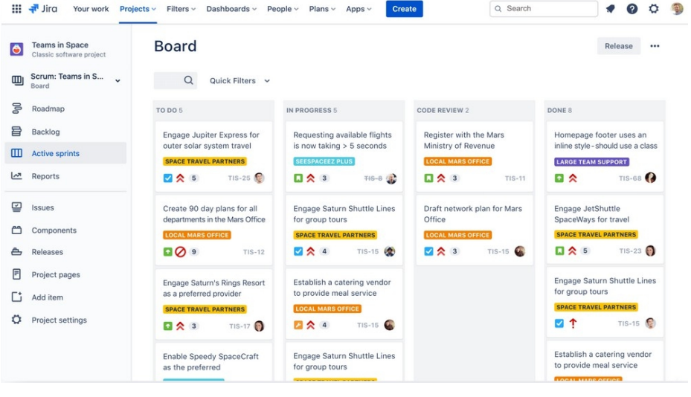

**Fig: Dashboard of JIRA**

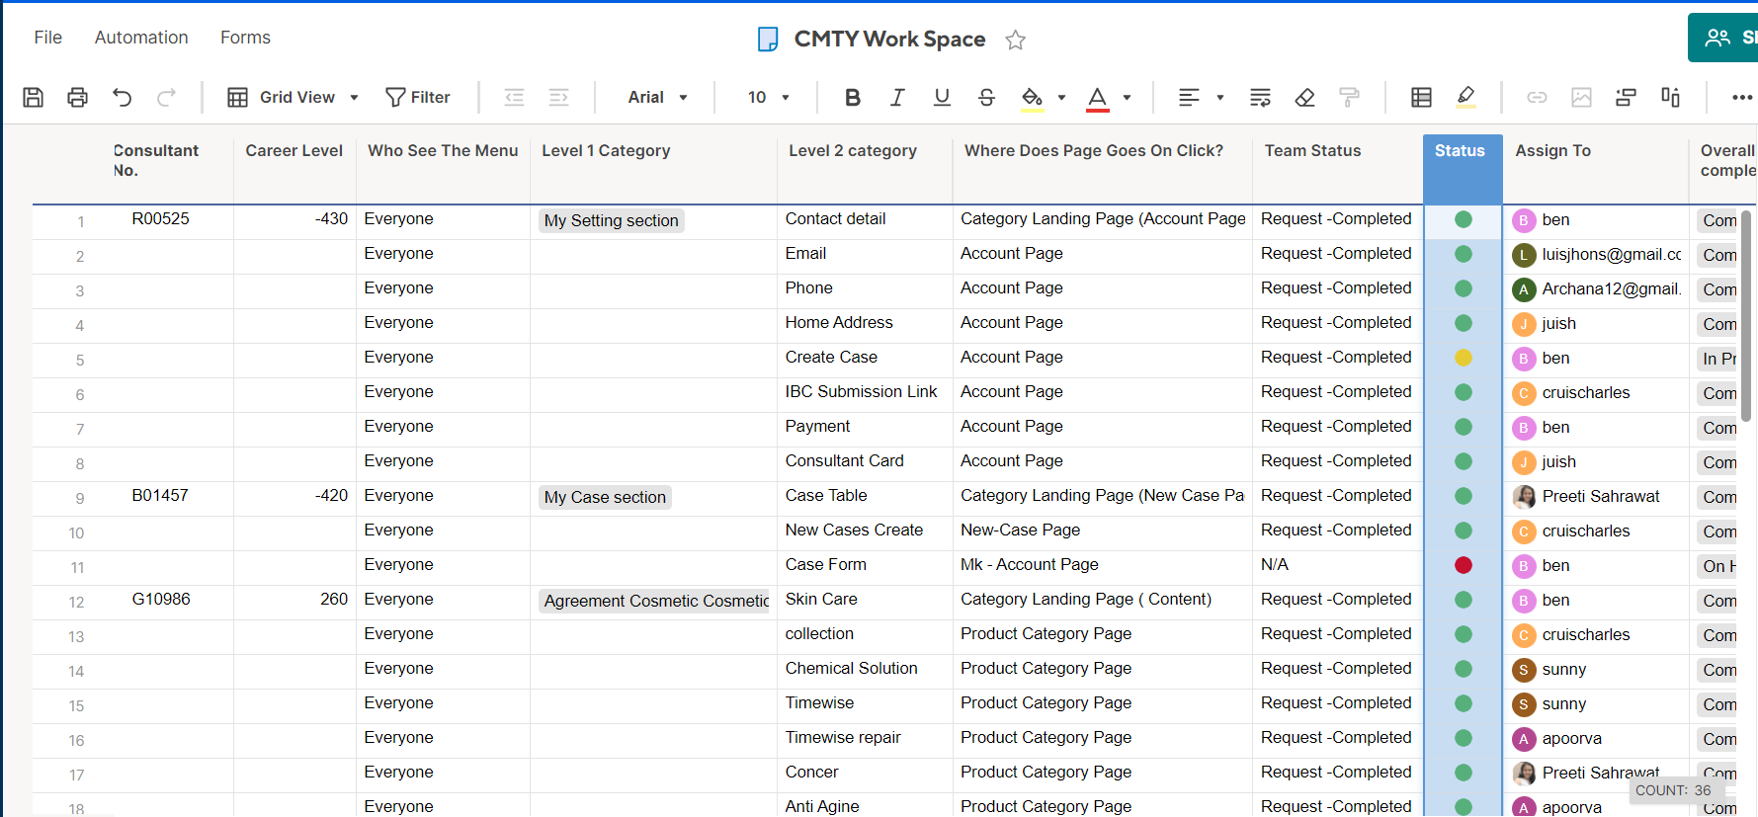

**Fig: SmartSheet**

**2.2.3. Tricentis TOSCA:**

**TOSCA Testsuite is a software tool for the automated execution of functional and regression software testing.**

**Besides testing automation functions, TOSCA includes**

* Integrated Test Management
* Command Line Interface (CLI)
* Application Programming Interface (API)

The test suite supports the entire lifecycle of the test project. It starts with transferring and synchronizing specifications from the requirement management system.OSCA supports its users in creating efficient test cases methodologically.

Tricentis Tosca combines multiple aspects of software testing (test case design, test automation, test data design and generation, and analytic) to test GUIs and APIs from a business perspective.

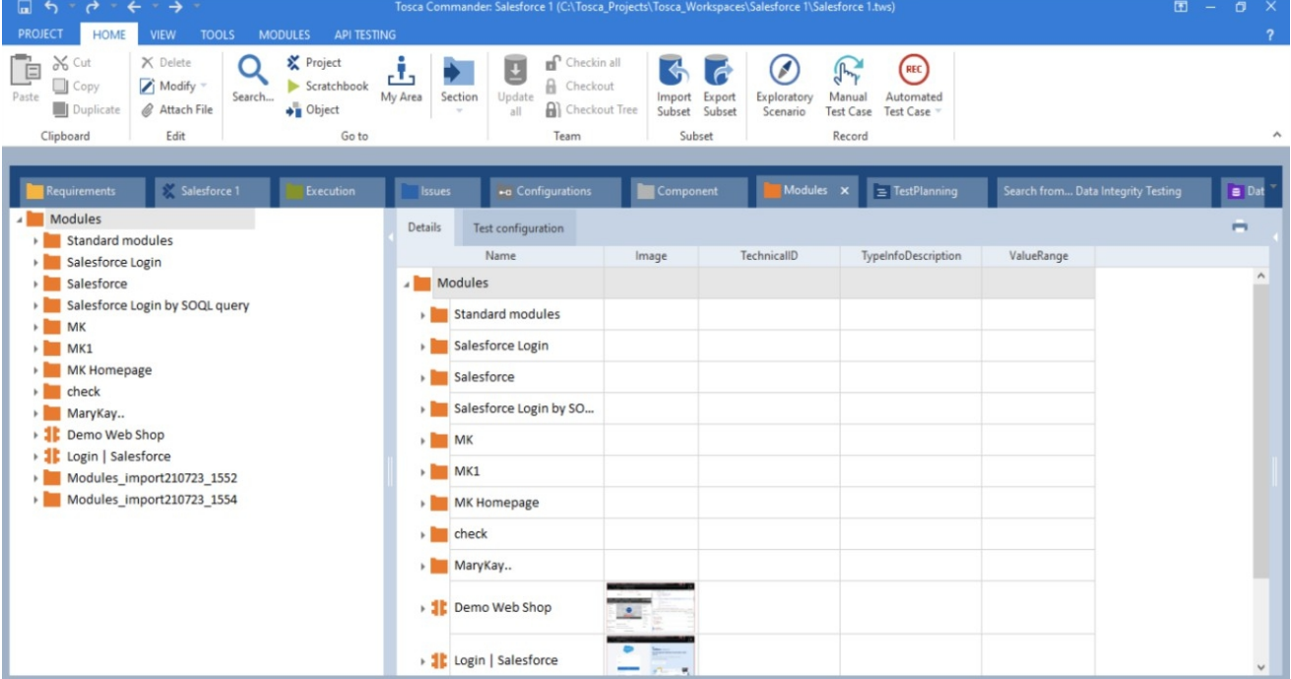

**Fig: View of TOSCA Test Suite**

This is the graphical user interface of TOSCA Testsuite™. It is considered to be the core of the test suite. The commander uses a “Workspace” for the administration of test cases. That means it enables the easy creation, management, execution and analysis of test cases.

**2.2.4. Salesforce Lighting Experience:**

Salesforce is a popular CRM tool for support, sales, and marketing teams worldwide. Salesforce services allow businesses to use cloud technology to better connect with partners, customers, and potential customers.It provides CRM and applications focused on sales, customer service, marketing automation, analytics, and application development. Salesforce Platform (also known as Force.com) is a [platform as a service](https://en.wikipedia.org/wiki/Platform_as_a_service) (PaaS) that allows developers to create add-

on applications that integrate into the main Salesforce.com application.These third-party applications are hosted on Salesforce.com's infrastructure.

**2.4.1. Workspace and Builder Experience:**

Create Workspace and manage dashboard , administration , Builder , CMS and set the layout of site and other functionality . Salesforce Builder can be used to customize the Community based on our business needs, without doing any custom development, we can customize the Community branding very easily and quickly.

**2.5. Community Cloud:**

Community Cloud provides Salesforce customers the ability to create online web properties for external collaboration, customer service, channel sales, and other custom portals in their instance of Salesforce. Tightly integrated to Sales Cloud, Service Cloud, and App Cloud, Community Cloud can be quickly customized to provide a wide variety of web properties.

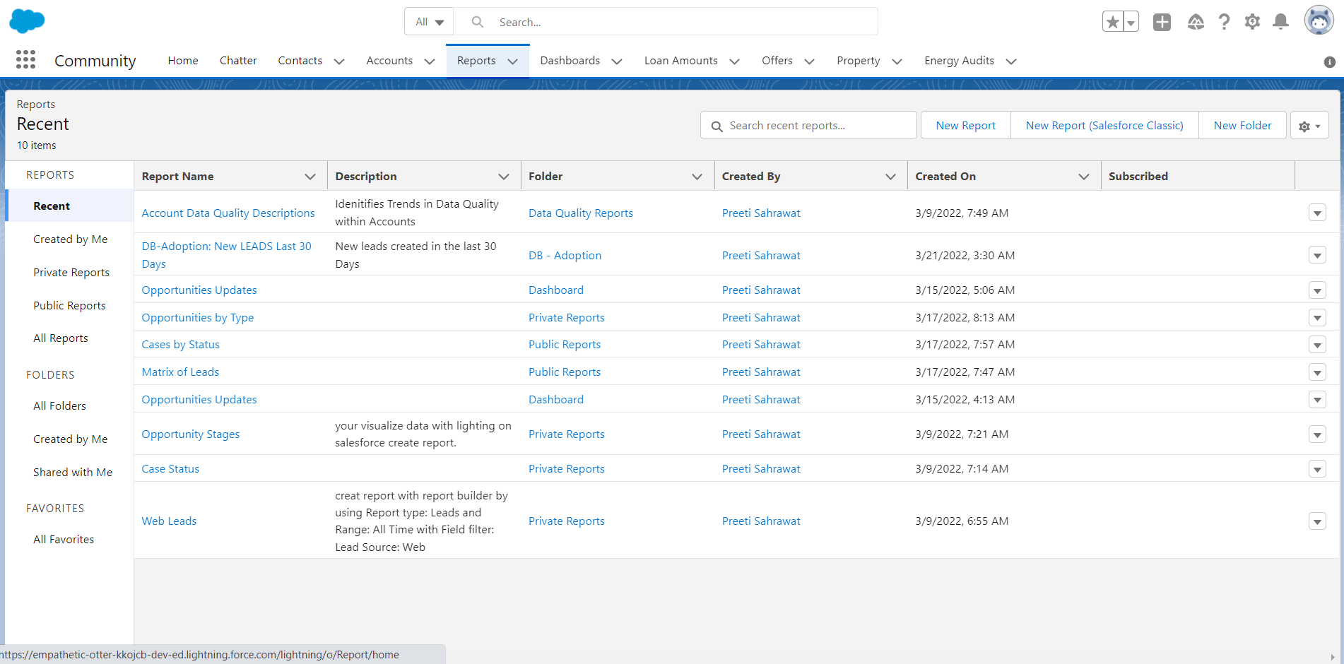

**Fig: View of Community Cloud Report**

**2.6 Commerce Cloud:**

Salesforce Commerce Cloud is highly scalable, Salesforce Commerce Cloud is the leading B2B and B2C ecommerce platform for delivering AI-powered commerce experiences.

cloud-based software-as-a-service (SaaS) ecommerce solution. The basic proposition of the platform is that, by offering ecommerce as a SaaS solution, it frees your business from the demands of managing a technical roadmap – or figuring out how to stay ahead of the curve when it comes to best practice ecommerce features.

The rationale is that Salesforce Commerce Cloud is constantly evolving and refining its features and functionality to keep pace with the fast pace of change within the ecommerce sector, so that you always have a best-in-class feature set.

**The Cloud Analogy QA team handled all its Quality Assurance activities in following manner:**

1. Studied and documented the flow of every Product related to the CRM.

2. Created test cases from the perspective of an app user i.e., Client and Subscriber

3. Created 10000+ test cases to capture every detail.

4. Tested the functionalities in different environments like QA, UAT and Production

5. Verify in the database for different records present on the UI.

6. Reported issues on Jira.

7. Retesting after issue resolution.

**CHAPTER - 3**

**REQUIREMENTS**

**3.1.Hardware and Software Requirements**

**Software Requirements**

• Browser (Google Chrome or Mozilla Firefox)

• Operating System (Windows 7 or above)

• Tricentis Tosca

(CPU i5 Dual-Core 2.4Ghz ,RAM 8 GB , Hard disk space 10 GB ,Network 100 Mbit/s)

• Qtest

• Atlassian JIRA

**Hardware Requirements**

• Processor i3 or above

• Hard disk 500GB or above

• Ram 3GB or above

• Peripheral Devices: -Keyboard -Mouse

**3.2. IMPORTANCE AND APPLICABILITY**

Software Testing is the process of critical analysis to identify and evaluate whether the developed application meets the Business Requirement Specifications. It is a continuous process, namely Software Testing Life Cycle (STLC) works along with the software development life cycle. Over each phase, it verifies the functionalities and validates the app performance with the requirement.

Besides, to deliver bug-free software, software testing helps to improvise the functionalities and usability of applications. There are different types, methods, and techniques to test software, and it involves multiple levels to verify and validate it.

To put it simply, the importance of software testing can be traced from the user’s response. It assures the quality of the product and satisfies the customers as well as users. Also, it promises better business optimization (less maintenance cost), reliability, and superior user experience. Substantially, the iterative efforts spent to mold a powerful yet error-free software are far and wide.

The importance of software testing and quality assurance is of high value in a software development cycle. Both of the processes refine the whole process and ensure superior quality to the product. Also, it reduces maintenance costs and provides better usability and enhanced

functionality. When software testing signs and pushes the individual components, quality assurance attests to the product- Fit for the purpose.

**CHAPTER - 4**

**PROJECT WORKFLOW**

**4.1 Project Roles and Responsibilities**

• Understanding Requirement Specification

• Taking part in Requirement Walkthrough

• Configuring Standard or Custom Object

• Module object writing

• Test Case Writing

• Taking test case walkthroughs

• Executing the test Suits

• Taking Libraries and test design sheets

• Closing all reported bugs

• Create and Raises Issues Types and Stories

• Verifying data of salesforce using Workbench

• API Automation

**4.2. Advantages Of The Application**

1. Products are safe, effective and deliver the benefits customers want.

2. Mary Kay spends millions of dollars and conducts more than a half million tests to ensure that Mary Kay.

3. Products meet the highest standards of quality, safety and performance. As part of the ongoing commitment to ensure that Mary Kay products consistently meet or exceed customer expectations.

4. Mary Kay better understands the benefits women want from the products they use.

**4.3.Testings Performed**

**• Smoke Testing:** The team assured that the critical functionalities of the system are working fine.

• **Sanity Testin**g: The team ascertained that the bugs have been fixed and no further issues are introduced due to these changes.

**• Functional testing:** The team was concerned about the functional flow of the modules to ensure that the application behaves as it should.

**• Regression Testing:** The client wanted to ensure that the existing features in QA must not get adversely affected on Sandbox and Production environments.

**• End-to-end testing:** a methodology used in the software development lifecycle (SDLC) to test the functionality and performance of an application under productlike circumstances and data to replicate live settings.

**Future Scope:**

• Take part in one of the best direct selling incentive programs in the industry .

• Your annual sales report will also determine if you are eligible to become part of this cosmetic website.

• Mary Kay Independent Beauty Consultants operate like their own business, which means they have control over when to start and when to stop. When it comes to your schedule and how quickly you want to move up the ladder of success, it’s your call.

• You can earn up to 50% by selling Mary Kay products at recommended retail stores.

• you can create a team and train them to sell our product, so that you can earn rewards, cash offers, and sales commissions from your team members.

• In addition, the quality and quantity of the products is guaranteed.

• The company’s beauty products include skin care, color cosmetics, body products, and perfumes etc.

**4.4. ACTIVITIES AND EQUIPMENTS HANDLED:**

The major tasks assigned to me during my internship at Cloud Analogy was:

To perform Manual Testing for various Salesforce UI like Alpha Finance, RideShare rentals.

To perform Automation Testing we need to use a tool named Tricentis Tosca.

To perform Manual and Automation Testing for Leads Connection CRM Sprint tickets and file bugs corresponding to them in JIRA .

**CHAPTER -5**

**DATA FLOW DIAGRAM**

**5.1. Level 0:**

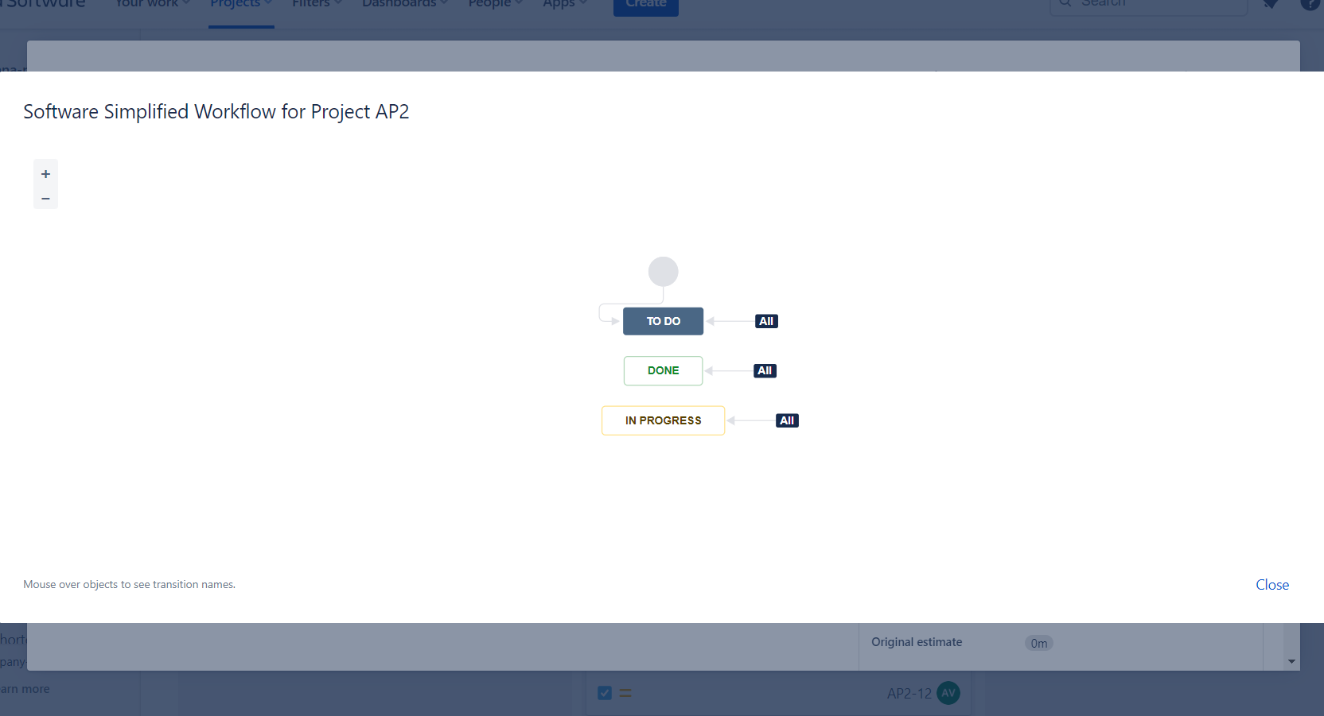

**5.2. Level 1:**

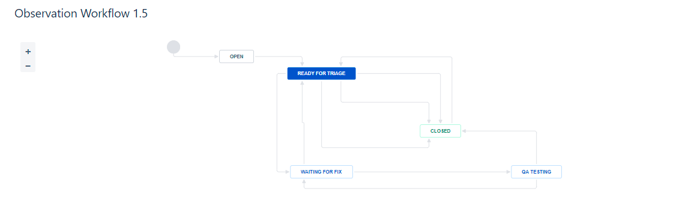

**5.2. Level 2:**

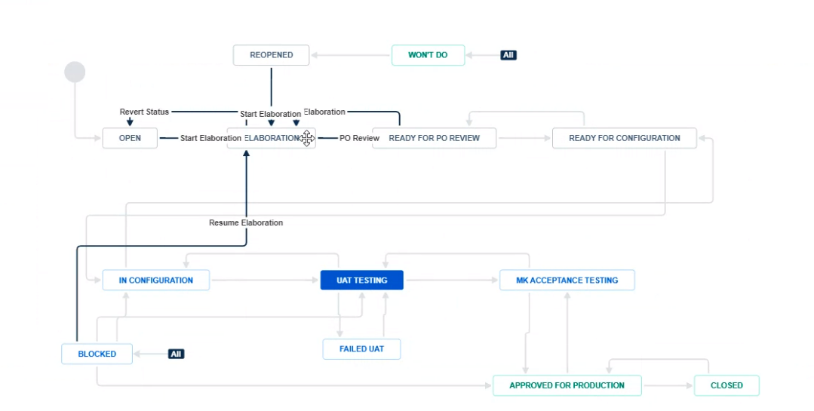

**CHAPTER - 6**

**CHALLENGES AND LEARNING**

**6.1. CHALLENGES FACED AND HOW I TACKLED THEM:**

The major challenges faced by me during my Internship was that I was totally new in the field of Quality Assurance. So I had not much idea about how the Software Development Life Cycle goes on in the industry. I also had a very fair idea about the test cases. The major challenge that I faced was learning the Automation Part. Cloud Analogy has been working on the Tricentis Tosca which is an automation tool and At the initial stage, I am not able to scan the modules and be able to make the X path properly.

Other challenges faced by me were to operate the JIRA tool for raising the bugs that were found by me during performing the manual testing of CRM entities. As I had no idea of how to log bugs and tasks assigned to me on JIRA, I took help from my fellow team mate My Mr. Prashant Dixit, Senior QA engineer. He was very kind and generous to me and he was the only person who assured me that I can contact him anytime if I want to have my doubts clarified related to the tasks assigned to me or getting some clarifications on the Tickets related to CRM. He also gave me a daily KT (Knowledge Transfer) Session of 30 minutes for 3 days which helped me get comfortable with the Automation Framework of Cloud Analogy.

**6.2. LEARNING OUTCOMES:**

The learning outcomes that I acquired from this internship are getting the required skills while doing the Quality Assurance Internship at Cloud Analogy. From this internship, I learnt the basic skills required in Manual and Automation Testing which are writing the critical Scenario Test cases and executing them manually as well as automating them through the automation framework.

From this internship, I learned about the Salesforce Customer Relation Management Tool and in which departments we used the Salesforce and How can we build any UI without coding. i also improved my communication skills as during this internship we have to work remotely, so I have to attend the daily SCRUM calls with the Product Management and the Developer teams to get a fair idea of the SPRINT tasks and the build deployments according to the bugs raised and being solved the Developer Team.

Based on my experience, I would say that the best start for a fresher in testing industry would be to start as a manual functional tester and learn all the values of testing and intricacies in testing which is about writing test cases, understanding functionality of applications, understanding different kinds of testing, what are the different things involved in functional testing, getting knowledge on areas like test cases, test scenarios, use cases, Bugs, Bug life cycle, best practices, system testing, regression testing, upgrade testing, UAT, test scoping, analysis and etc.Over a span of 4 months, I was able to equip myself with a lot of new things.

Those are:

1.Importance of functional testing for a web CRM application

2.Working in Team for effective results

3.To have good communication with the team in order to convey and get ideas or issues.

4.Integrate theory and practice.

5.Assess interests and abilities in their field of study.

6.Learn to appreciate work and its function in the economy.

7.Develop work habits and attitudes necessary for job success.

8.Develop communication, interpersonal and other critical skills.

**CHAPTER - 7**

**Q-TEST METHODOLOGY**

**7.1. Q-Test**

qTest is a test management tool used for Project Management, Bug Tracking, and Test Management. It follows the centralized test management concept that helps to communicate easily and assists in rapid development of tasks across the QA team and other stakeholders.

qTest is a cloud based tool and was developed by QASymphony. It supports all browsers especially Chrome, Firefox, IE, etc. and also supports different windows OS versions – Windows XP, Vista, 7, etc. QTest provides a 14-days trial period for Business email id with access to 4 users. qTest can be integrated with many other tools – JIRA, Bugzilla, FogBugz, Version One, etc.

### License and Free Trial

Following points are related to the License and Free Trial of qTest and related services.

* qTest is a commercial tool and available as a trial version for a limited period of 14 days.
* To utilize JIRA services, a license is required.
* qTest provides a free license for Business Email ID.
* The basic version (free trials) comes with access for 4-people groups.

**7.2 Uses of qTest**

Following are the different uses of qTest −

* Used in tracking all QA activities right from the first phase of the software testing life cycle.
* Supports Release Management, Build Management, and Module Management.
* Supports all macro level activities performed by QA.
* Useful in performing QA tasks such as writing TestCases, execution, reports, etc.
* Useful in Project Management, Task Tracking, Requirement Management, and Test Management.

**7.3 qTest - Login**

Follow these steps to login to qTest.

Step 1 − Go to your sample website selected while creating the free trial. It will open a login page.

Step 2 − Enter your registered business email address as Username and Password.

Step 3 − Click the LOGIN button.

The following screenshot shows how to login into qTest using credentials.

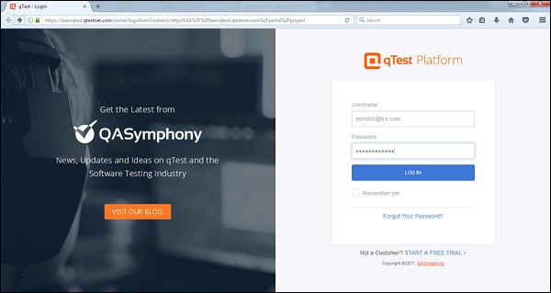

## **On Error**

Let us now understand the situation wherein your login attempt is unsuccessful.

When a login attempt is unsuccessful, the following error page displays.

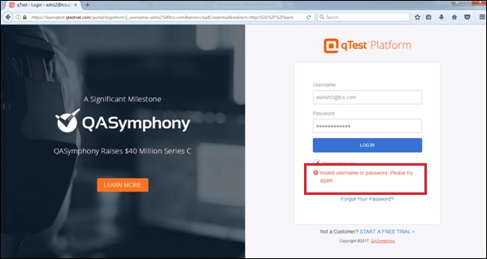

Error may occur due to wrong combination of email id or password.

Following screenshot shows the error message that a user receives, if the credentials are not correct −

If you forgot the password, to recover it −

* Click on the Forgot Your Password? link below the error message.
* Enter the Login Email
* Click Submit

The following screenshot shows how to recover the password if you forgot.

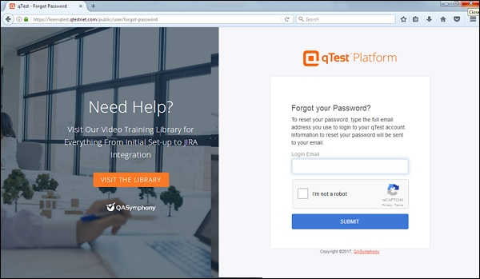

You will get an email with the details of username or link to reset the password.

## 

## **On Successful Login**

Upon successful login, the system dashboard will display if the account is associated with any project by admin or if you can create a sample project.

The following screenshot displays the welcome page/dashboard of qTest on successful login.

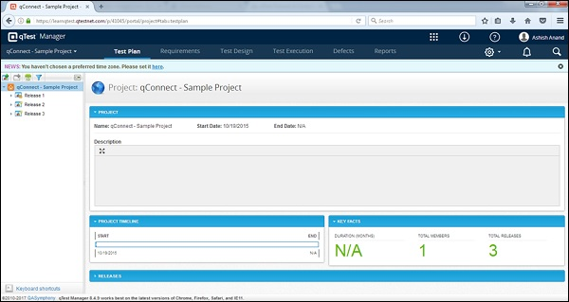

**7.4. DASHBOARD:**

After logging into qTest, Dashboard is the first page that is displayed. The Dashboard is customized by Admin. Based on the roles, the admin can set the access to qTest.The admin even has the right to change the colors and logo of qTest.

Following are a few important points relating to the qTest Dashboard −

* The navigation bar, present at the top of the qTest page, will be the same across all pages/screen of qTest.
* qConnect − <Project Name>, Test Plan, Requirements, Test Design, Test Execution, Defects and Reportsare the main links. These links are used to navigate to respective functionalities.
* Navigation bar contains links that provide quick access to the most useful functions of qTest.
* By Default, the Test Plan page of the default project displays on successful login.
* Below the navigation bar, the News bar of the page has an advisory to set a time zone as “You haven’t chosen a preferred time zone. Please set it here.”
* The information provided on the left side of the white area is related to the releases of project along with a few exciting features of qTest.
* On the right side of the Navigation bar, Settings, Notification and Search are the main features and remain the same across all pages/screen of qTest.
* On the right side, above the navigation bar, there are few links – qTest Apps, Resources, Repository, and Help for qTest and Profile Summary.
* On the left bottom, there is a link – “Keyboard Shortcuts”. When you click it, it displays different keyboard keys combination to navigate to a specific functionality.
* Shift + D = Create Release  
  Shift + C = Create Build  
  Shift + X or Shift + Delete = Delete Object  
  CTRL + G = Save objects and move next

The following screenshot shows the overview of the Dashboard page of qTest.

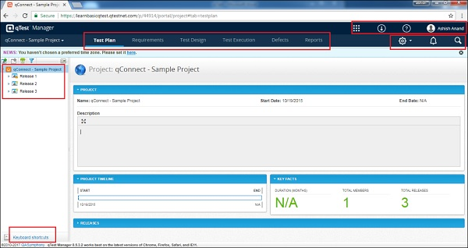

## 

## **qTest Apps**

qTest has many different apps. The most widely used app is the qTest Manager. Along with this, qTest also has Session, Insights, Parameters, and Pulse. These apps come with a lot of advantages and can be used along with the qTest Explorer and others.

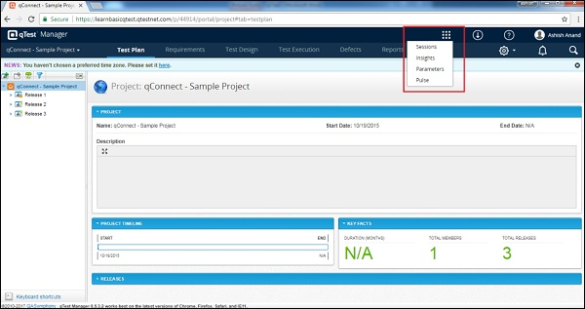

## **Repository:**

It has many sub-links to access different documents about qTest. These documents provide information about qTest and also extend knowledge to new users on the functionalities of qTest. These documents also help to find a solution if you don’t know how to accomplish a particular task.

The repository contains links to the following −

* Knowledge Base − It provides information about the other apps of qTest.
* Video training − It provides training to new users. New users can go through it to know the different functionalities and how to use qTest.
* Request Pricing − A user can ask to provide a pricing chart based on the requirements.
* Get Help − It is a documented section where a user can find all basic/advanced functionalities of qTest and can know how to use those.
* Submit Ticket To QASymphony − The main purpose of this link is to provide real-time support to the users at instances, where they find difficulties in accomplishing tasks. This does not support free-trial users.
* Suggest New Features − Here, a user can provide suggestions or feedback relating to qTest, which will make it more user-friendly.
* About qTest − It provides the details of qTest such as Versions and Copyright Info.

Following screenshots shows the different documents available under Repository.

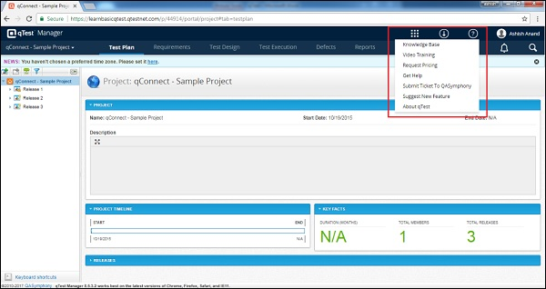

## **User Profile:**

By clicking the profile link, you can view your personal profile as My Profile and Company Profile as Company Profile and manage the sections. By clicking Logout, you will go back to the login page and will not be able to access the project details without logging again.

Administration is the role, the availability of which depends on the logged-in user’s role. If the user is an administrator, only then this link will be present. In free trials, all users are administrators by default.

Following screenshot shows the available functionality under the User-Profile section.

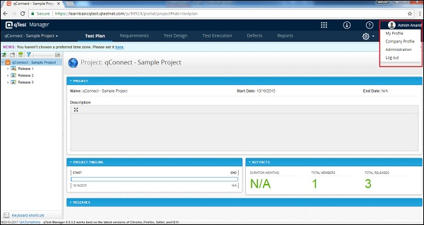

### **My Profile:**

By clicking My Profile, you can view and edit the details of your account. You need to click Save to save all edited details. There is additional functionality to change the password here. After entering the required details, click Change Password to activate a new password.

Following screenshot displays the account information and the change password section.

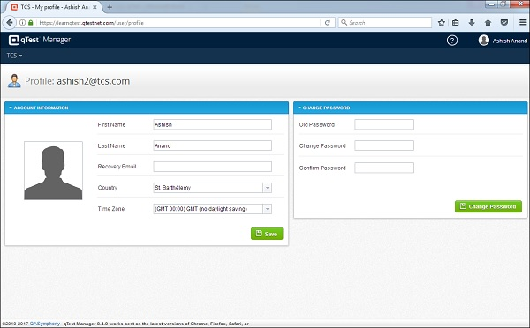

### **Company Profile:**

By clicking the Company Profile link, the basic information of the company is displayed. These are the details entered while registering. You can edit and add new details. Click Save to save the details.

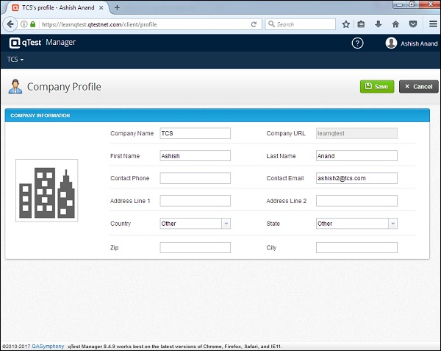

7.5 **qTest - Add a Project**

Create a Project

Following are the steps to add a project into qTest.

Step 1 − Go to the user profile section and click Administration as shown in the following screenshot.

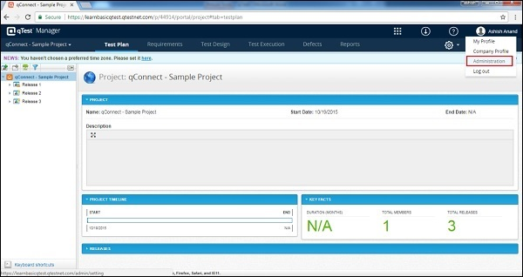

By default, the Project tab displays the +Add new project button as shown in the following screenshot.

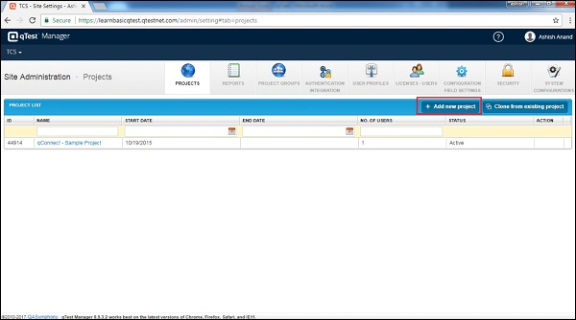

Step 2 − Enter the Project Name, Start and End date, Description and assign users as admin as shown in the following screenshot. Then, click the +Add button at the bottom.

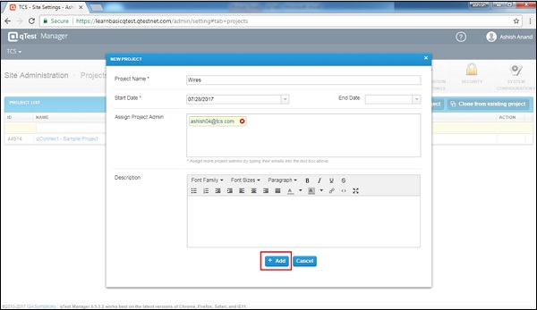

By clicking the +Add button, the project gets added successfully and a dialog box appears along with the OK button as shown in the following screenshot.

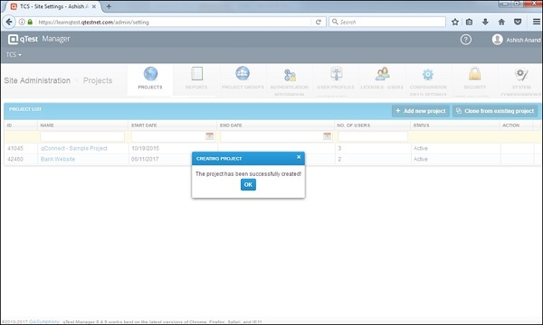

Step 3 − Click OK and you will be able to see the newly added project in the table.

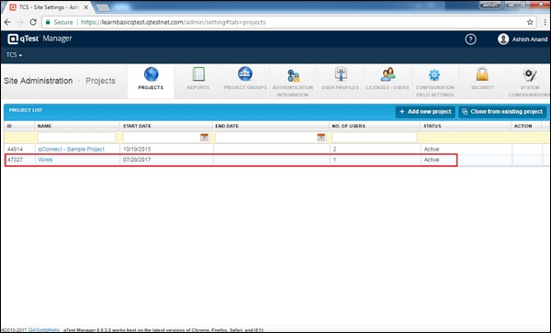

Step 4 − You can access this project by clicking the options on the top left corner of the screen and selecting the project name as shown in the following screenshot.

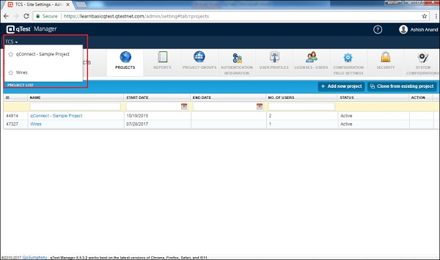

By clicking the Project name, the Test Plan page of the corresponding project is displayed.

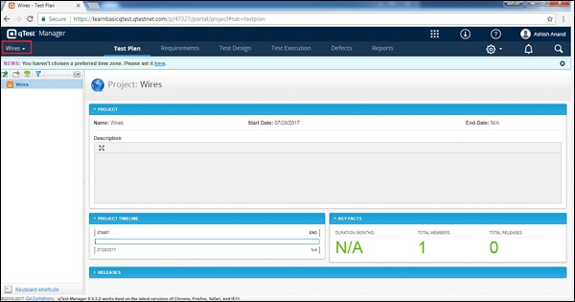

**A.Scrum boards:**

Jira’s Scrum board is a tool that unites engineering teams to work towards their goals. It allows engineering teams to complete all their sprint tasks in a consolidated area.Scrum boards allow teams to organize their workload to fit inside a particular sprint. They also help you keep track of your project stages to keep things moving along.

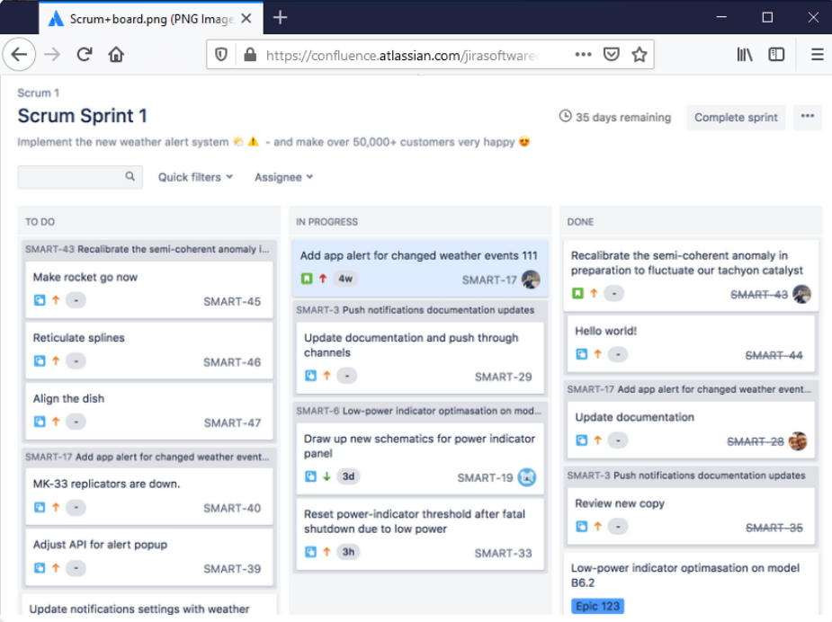

**B.Kanban boards**

Kanban boards are a handy way to visualize your workflow. Here, your tasks are laid out on a board like sticky notes (get rid of those Post-It’s, Jim!):Each sticky note shows the status of an individual project task. These statuses include – ‘to do,’ ‘in progress,’ and ‘done.’They give you a bird’s eye view of the Jira project to help you quickly identify:Which tasks are running smoothly Which tasks are bottlenecking the processes.You can use this view to track bug fixes, conduct code review, and monitor other tasks which may or may not be engineering related.

Jira’s Kanban board is based on a drag and drop system, which makes this tool super easy to use. All you have to do is drag a task and move it to the next stage to keep everyone updated!

**2. Custom workflows**

A Jira workflow is a set of processes that need to be followed in order to complete a task or resolve an issue. A custom workflow activity **allows you to add complex processing steps to your configurable workflows**. Custom Workflows can be run on demand as well as after triggering an event. Workflows can be configured by power users using a point and click user interface.

**3. Roadmaps**

A project road map allows you to create a clear vision of the product you are developing. This gives your team a set direction and path to follow.

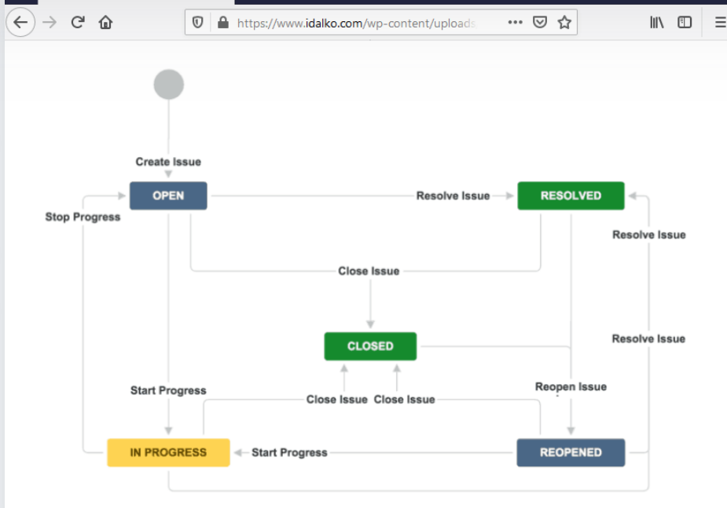

**CONCLUSION**

In Conclusion, during my Internship at Cloud Analogy, I learnt a lot apart from theoretical coordinate the work they are doing with colleagues. In Cloud Analogy, since the starting of Internship I have worked on various domains like Salesforce Page creation and Manual Testing, also some of general-purpose tools which I used are Slack, JIRA, Confluence, Citrix, Tricentis Tosca ( Automation tool ) and Qtest.

My role at Cloud Analogy was focused on Manual and Automation Testing which is very challenging as we need to take care of a lot of things like work as per deadline, meet the client requirements in minimum time span and error free so that it adds value to the productivity of the company. With this we also have the mange security norms as no one outsider can access the company resource and one who has provided access needs to be as per role of that user for the company. Because of this internship I get to know how things work behind the website or mobile application and how we can create high availability of the resources so that it can be more productive.

Due to these roles and responsibilities, I learnt so much about interpersonal skills, making connections, independence, working hard no matter what you’re doing, taking constructive criticism well, networking, and professional communication.

Also, during the time of my Internship I learnt that what you learnt in college are helpful but not sufficient, so you have to acquire new and improved skills and how to apply them to solve the problems in work and in life as well.

The report discussed all the aspects needed to justify the project. In this Project, I have extended my knowledge of the important ideas in software development. We investigated the characteristics of a good software system, and considered what a development process would need to include to build such software.

I learnt that it is good practice to split a project into smaller, more manageable activities.When developing good software systems, you should focus on the user’s needs and, wherever possible, make use of replaceable and reusable modules – components.After completion of Project Report, I can conclude that Manual and Automation Testing can help to improve the site in much better way. As no machine can ever win in-front of the human mind.

**FUTURE PERSPECTIVE**

Based on my experience, I would say that the best start for a fresher in testing industry would

be to start as a manual and automation tester and learn all the values of testing and intricacies in testing which is about writing test cases, understanding functionality of applications, understanding different kinds of testing, what are the different things involved in functional testing, getting knowledge on areas like test cases, test scenarios, use cases, , exit and entry criteria, Bugs, Bug life cycle, best practices, system testing, regression testing, upgrade testing, UAT, QA, test scoping, analysis and etc.

And if you are having good knowledge in programming, in the non-office hours also keep track of your programming skills by learning any automation tools like selenium, which will help you in creating test automation scripts and keep yourself updated. This might help to give you good career growth and knowledge.

**REFERENCES**

1.Becken, S., Alaei, A. R., & Wang, Y. (2019). Benefits and pitfalls of using tweets to

assess destination sentiment. Journal of Hospitality and Tourism Technology.

1. Zongben Xu, Xinbo Gao, Qiguang Miao, Yunquan Zhang, Jiajun Bu (Eds.)., 6th

CCF Conference, Big Data 2018 Xi’an, China, October 11–13, 2018

Proceedings,Springer.

3. Basiri, M. E., Nemati, S., Abdar, M., Asadi, S., & Acharrya, U. R. (2021). A novel

fusion-based deep learning model for sentiment analysis of COVID-19

tweets. Knowledge-Based Systems, 107242.

4. T. A. Ashwitha, A. P. Rodrigues and N. N. Chiplunkar, "Movie Dataset Analysis Using

Hadoop-Hive," 2017 2nd International Conference on Computational Systems and

Information Technology for Sustainable Solution (CSITSS), 2017, pp. 1-5, doi:

10.1109/CSITSS.2017.8447828.

5. Kune, R., Konugurthi, P. K., Agarwal, A., Chillarige, R. R., & Buyya, R. (2016). The

anatomy of computing. Software: Practice and Experience, 46(1), 79-105.

6. Wang, J., Xu, C., Zhang, J., & Zhong, R. (2021). analytics for intelligent

manufacturing systems: A review. Journal of Manufacturing Systems.

7. Costa, R. L. D. C., Moreira, J., Pintor, P., dos Santos, V., & Lifschitz, S. (2021). A

Survey on Data-driven Performance Tuning for Big Data Analytics Platforms.

Research, 25, 100206.

8. Uzunkaya, C., Ensari, T., & Kavurucu, Y. (2015). ecosystem and its analysis

on tweets. Procedia-Social and Behavioral Sciences, 195, 1890-1897.

9. Mohammed M. Alani, Hissam Tawfik, Mohammed Saeed, Obinna Anya, Applications

of Analytics, Trends, Issues, and Challenges, Springer.

10. Zhai, Y., Tchaye-Kondi, J., Lin, K. J., Zhu, L., Tao, W., Du, X., & Guizani, M. (2021).

Perfect File: A fast and memory-efficient metadata access archive file to face

small files problem in HDFS. Journal of Parallel and Distributed Computing.

1. FEI HU, Sharing Storage and Security, CRC Press Taylor & Francis Group.

12. Kalia, K., & Gupta, N. (2020). Analysis of hadoop MapReduce scheduling in

heterogeneous environment. Ain Shams Engineering Journal.

13. Ashwitha T AAnisha P Rodrigues Niranjan N Chiplunkar, Movie Dataset Analysis

using Hadoop-Hive.

14. Lucas Filho, E. R., de Almeida, E. C., Scherzinger, S., & Herodotou, H. (2021).

Investigating Automatic Parameter Tuning for SQL-on-Hadoop Systems.

Research, 25, 100204.

15. Ammar Fuad, Alva Erwin, Henru Purnomo Ipung, Processing Performance on Apache

Pig, Apache Hive and MySQL Cluster, IEEE, 2014 International Conference on

Information, Communication Technology and System.

16. Shujia Zhou et al., Visualization and Diagnosis of Earth Science Data through Hadoop

and Spark, 978- 1-4673-9005-7/16/2016 IEEE International Conference.

17. Karan Sachdeva et al., Comparison of Data Processing Tools in Hadoop, IEEE, 2016

International Conference on Electrical, Electronics,Communication, Computer and

Optimization Techniques.

18. Aditya Bhardwaj et al., Big Data Emerging Technologies: A Case Study with Analyzing

Twitter Data using Apache Hive, IEEE, 2015 RAECS UIET Panjab University

Chandigarh